NCSE 2.9.21

Kevin – Safety moment – Following the fatal injury of a 5 year veteran employee who unintentionally removed the final pieces of hardware from a form he was stripping, before the crane was hooked up, McCarthy has created the tags below. These tags serve as visual reminders not to remove the final hardware connections before the crane or other equipment is rigged up to support the formwork.

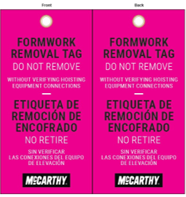

Anthony – Vehicle accidents down. Working with Dekra (ongoing). Performance predictors outlined – 7 leading indicators being reported on that seem to be telling. Sustainability added to EHS reporting function. Exploring talk to text options.

Bob – Nothing to report other than got his first vaccine dose!

Brad – Senior leader connection to plants and constructions sites being strengthened through location visits. Breaking into teams of senior leaders and interviewing a diagonal slice of the site – plant leaders, front line leaders, craft…getting real feedback and helping them connect to the sites. Assessing and understanding lifesaving rules, performance standards, etc…

Jason = Addressing man overboard / pipe connections in open sea through procurement of two new knuckle boom rigs. Presented to leadership and were approved - $30M price tag on each, reduces manual labor for workers and reduces man overboard risk.

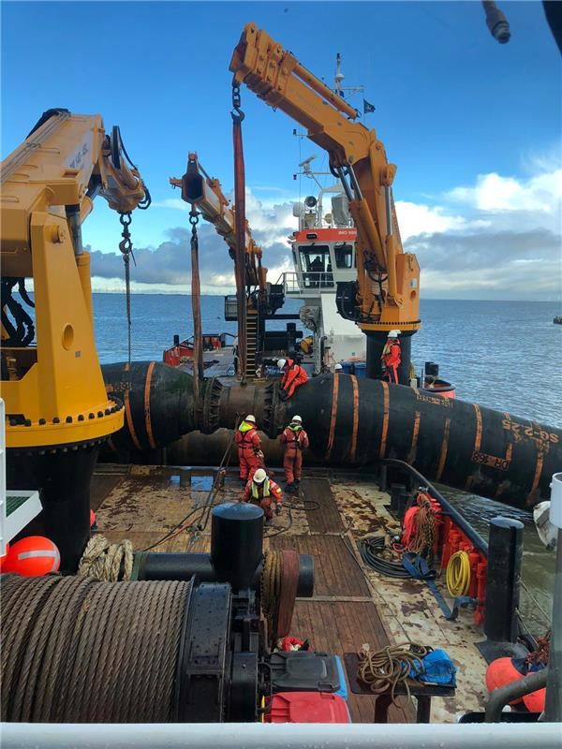

Matt- Stky is a 3 to 5 year journey. 20000 people through training. Focus on discussions. Drive discussions to workplace. Refine job briefing process to make it for the worker not for the safety pro that is auditing them. 29% reduction in stky events this year. Missed training leaders as well as they could have, new play book for how to run stky in your group is focus for spring training of leaders.

Dan – Finalizing 2020 stats which are 25% of bonus. Rebranding OI cares, working with Scott Gellar. Trying to make 2021 about visibly demonstrated care.

Marni – ASK – Gap analysis postponed. Developing company assessment to evaluate consistency of implementation and application with focus on leadership engagement, craft engagement, planning and accountability. Looking for value added examples of company assessments. Not check the box, numerical score driven checklists that add no value and lead to bickering over whether something is a 3 or a 4…but tools that actually help assess culture as well as the presence of safety on a site as opposed to just the absence of injury.

Alicia – Focusing on collaboration across organization as they have been relearning lessons from one location to another. High potential incident and near miss focus. Working on dashboards and insights. Dashboard snapshot sent to each employee daily with SIFs to bring visibility to the incidents. Interesting to see what different groups have been doing with them / conversation it is creating. Covid…like the rest of us.

David K – Started “someone in transportation you should know” within organization. The individual gave a safety share and told something about themselves to create and build culture. Started out having to pull, now they are volunteering ACEC chapter David was asked to be a part of by his CEO awarded New Year chapter an award for their Covid Health and Safety plan that all 49 other chapters have adopted. Completing supervision transportation training that some companies in the “room” helped develop.

Dave H – ASK – Work zones – fatality due to work zone intrusion in November, San Diego. Driver fell asleep, 24 years old. Struck 41 year old employee with three kids at 50 mph. They had all of the right protections in place, no citation given. DOT is focused on driver convenience and moving drivers through work zones, NOT work zone safety. Those of us that do this work need to work together to influence our DOTs and how this work is accomplished in order to change things. Please let Dave know if you are willing to work together to change the way DOT expects work to be accomplished.

Jeff – Excyte continues to grow. 70 to 90% of staff are 3rd party CM. Working to find best way to bring people up to speed and create culture quickly. Implementing SIF / STKY culture in Asia and Europe based on what they are doing here and what has been shared by this group.

Jim – TNTS

John Johnson – Decent year for them, like many. Appreciation for craft people is a big focus for them this year. Also, helping engineers and designers understand how they impact people in the field by what they do. Near miss and haz rec program reinvigoration is a focus for them.

Kevin – Performance improved also leading to recognizing the field being a focus for the start of this year. Dashboarding is an effort underway, combining origami risk info in Power Bi to get real time dashboard with vital processes (leading indicators) violations, origami info, in front of leaders. Working to get to next layer of users – project managers. Orientation – 500 people through 90 min executive orientation. Drug and alcohol training – focusing on supervisor training for cause as marijuana laws change.

Mike – Good lagging indicators but not sure if they are lucky or safe for certain. Feels they are not accurately assessing risk. Weekly calls with SIF focus helping people recognize actual risk. HSE manual update. Reinvigorating IIF / BBS efforts / content from the group with Skanska. ASK – looking for suggestions on what has been effective.

Michelle – Data is a focus, doing a better job of trending leading indicators with better data. SIF program, respond to and learn from SIFs better. A couple of fatalities this year, how do we make sure they go home? Sharing of tribal knowledge – how do we pass it on to the next group of builders?

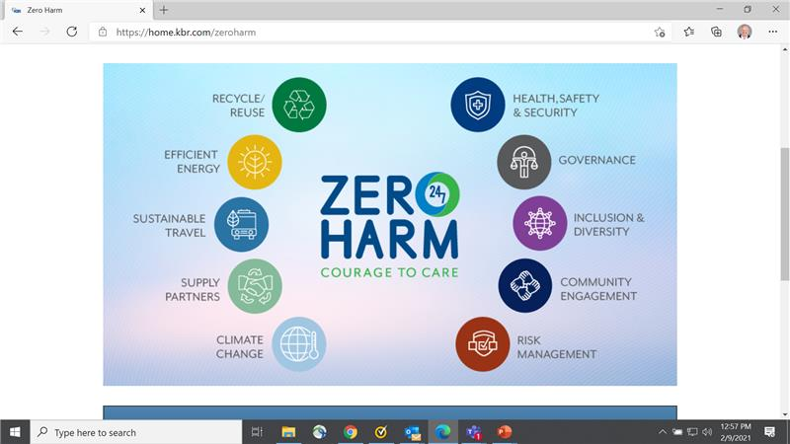

Nick – Staying focused on 9 pillars of Zero Harm, centralized message being courage to care. Sharing communications with sustainability. Leaning in to bring messages home, expand zero harm message and get it out front of the audience.

Troy – Safety team strengthened relationship with leaders through COVID experience. Ask – STKY – many events are the result of a release of energy with a missing control. Looking for help from people who have already identified “Life saving controls” which they will call STCKY controls. Two fatalities – formwork and tipped scaffold. B&G has new saying “we control the controls”. Focusing on crew work plan and what they need to have before they start to be safe, not stop the work after it is unsafe…no one does that. 10th Anti-collision device purchased for cranes thanks to input from this group.

Paul – Dashboards – anyone doing an inspection got a question of the week. 91%. Higher RIR than last year. Presented STKY content to board of directors for first time – which industries, stcky luck, etc… Using risk talk, talk to text (record actually) for safety meetings. Helmet trial – 4 models + chin strap.

Ziggy – 2021 is start of new company mission year for them (every few years). Several serious work zone events in 2020. Stky, SIFs, DOT worker protection in work zones. We have to care about our people, DOT does not care about workers they are focused on traffic and drivers. Reminder of survey and need to get your data in!

Andy – Moved to client side, Brookfield properties. $250B in assets. Engineering and maintenance, student housing in UK, hospitality. Risk for hospitality workers is a focus, building a strong and robust safety program from the ground up. Some of our companies are working to build their properties.

John – Bechtel had their best RIR and 2nd best lost time. Looking at loss potential and risk reduction. Asterisk on 2020 results due to Covid like many of us. Consolidating certs for ISO 14000 and 45000 – drives process improvement. Mental health program a focus this year, eliminating stigma and judgement for workers.

Smithgall, Steve - I have to drop to get ready for another meeting. I can summarize my 2 minutes - in 2020, we focused on the fatal four, and our HI-Po incidents (STCKY) were largely struck by exposures - specifically dropped objects. For 2021, we will focus on increasing safety observations with a new, user friendly app with excellent tracking capability. We also will be focused on temporary works - scaffolds, temporary bracing, shoring, shoring, etc - and treating them like permanent parts of the work - submitted, approved, 1st work inspections, etc. ,

Melissa and Micheal – Ogletree Deakins

* Osha – says you can require vaccine but need to inform employees of benefits
* Per ADA will need to make some exceptions even if you mandate.  Direct threat “clause” = high rates, shoulder to shoulder work, etc…
* Interactive process for accommodations.  Assume any medical condition counts as a disability and any sincerely held belief by and individual to count for religious exception
* Incentives – grant reasonable alternative to those with disabilities or sincerely held beliefs to create alternate minimum for those individuals to meet the intent of the offering but give them the chance to receive the incentive
  + Enhanced PPE
  + Work from home
  + OR ADA forgiveness of rule for certain individuals as the accommodation

Additional examples of accommodations – work from home, agree to regular testing (likely only financially feasible of you have your own clinics and access to saliva testing like colleges, enhanced social distancing.  Be ready to provide a business justification for why we did or didn’t provide an accommodation.

* As vaccine increases and rates decline, we’ll no longer have “direct threat” claim  - above 5% = community spread, below 5% = no community spread and likely no direct threat concern (consider engaging epidemiologist)
* Will we fire if people don’t get vaccine?  Draw line in the sand timeline for people to comply with recognition that vaccines are not currently available to most
* Consider our staffing plans.  If we require people to stay home when symptomatic and we decide to sponsor a clinic or onsite vaccine van, we could wipe out our own workforce for a week or two due to side effects.
* Logistics – how will we get enough, how will we prioritize it?
* OSHA recordkeeping – some people’s side effects are bad enough that they end up out of work.  Would that be recordable / lost time?  OSHA’s position on side effects is unclear but existing small pox guidance is the closest they can find and it says that if it is for the purpose of work and we provide it we could be on the hook for comp and OSHA.  If we provide it at work so that our employees don’t get sick through community spread and take down our operations, that may be different than if we provide it at work because our conditions put them in a position where spread is possible / likely.
* Prep Act  Covered persons and possibly sponsors are immune from liability for administering  countermeasures – may apply
  + Must have LHCP administer vaccine with current licensing.
  + Other counter measures such as masks not covered.
* Incentives can lead people to claim disparate treatment – reminder to create alternate minimum standard to meet
* If incentives are consider part of wellness, don’t forget the cap on incentives (30% of annual premiums?) many not have enough capacity to do incentives.  ERISA programs must be written.
* Is it a bonus?  Non-discretionary?  Worked into regular pay?
* Sweepstake model – if you get vaccinated you are entered into a drawing.  Run risk of creating a lottery which is based on chance and consideration.
* What if customer requires it?  Make sure our policy covers employees on other sites as well as other employees on our sites.  Who will cover the cost of vaccines or accommodations?  If we plan to mandate it, we should be talking to subs now about preparing and cost.

If mandate

* Tell subs now so they can get ready for spend
* Develop positive messaging on vaccine
* Train supervisors to support company message (don’t want foreman undermining leadership message to craft)

Stay informed, many states working on language

Ogletree Deakins does have a template plan available for a small flat fee.

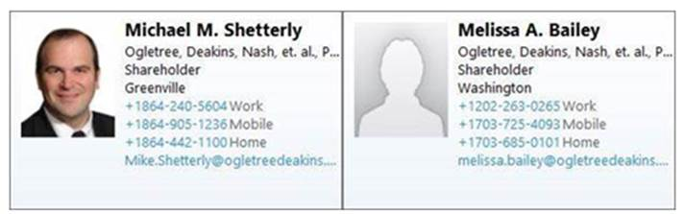

New member presentations: Fluor, Bechtel, Kiewit

All new members voted into group. Business meeting closed 3:11 PM.