October 3&4, 2018

The chairman, Paul Levin, convened the Fall 2018 meeting of the National Construction Safety Executives at 8:00 AM on Wednesday, October 3rd, 2018. Kevin Maitland shared the emergency procedures and Paul began introductions with new people in attendance. Members attending were:

Paul Levin, Chair Sundt pclevin@sundt.com
Cindy DePrater, Vice Chair Turner Construction cdprater@TCCO.com
Jerry Shupe Mbr at Large Hansel Phelps jshupe@hanselphelps.com
Tim Palmer, Treasurer Black & Veatch palmertd@bv.com
Kevin Maitland, Logistics McCarthy kmaitland@mccarthy.com
Marni Hogen, Secretary Mortenson marni.hogen@mortenson.com
Eric Grundke Kiewit eric.grundke@kiewit.com
Andy Peters AECOM andy.peters@aecom.com
Don Hurley Zachry Hurleyd@zhi.com
Jeff Kleinfelter HDR jeff.kleinfelter@hdr.com
Eric Zuhlke JE Dunn eric.zuhlke@jedunn.com
Matt Compher Quanta mcompher@quantaservices.com
Jason Campbell Great Lakes D&D jwcampbell@gldd.com
Jeff Dennis MW Group Jeffrey.dennis@mwgroup.net
Troy Ogden Brasfield & Gorrie togden@brasfieldgorrie.com
Rich Baldwin Emeritus awacspilot@yahoo.com
Anthony Miller Parsons Anthony.miller@parsons.com
Dave Hulverson Granite dave.hulverson@gcinc.com
Brad Barber GMBradley.barber@gm.com
Brad Giles Bradley Giles & Associates brad@bradleygiles.com
Tim Sirofchuck AECOM tim.sirofchuck@aecom.com
Brent Landry Bechtel Group blandry@bechtel.com

Members Absent
Steve Smithgall Balfour Beatty ssmithgall@balfourbeatty.com
Dan Helman, (H) Owens-Illnois dan.helman@o-i.com
Jeff Shoop Bechtel jshoop@bechtel.com
Bob Johnson Granite bob.johnson@gcinc.com
Page Warde Weeks (retired) pewarde@weeksmarine.com
Gary Amsinger Emertius gjamsinger@msn.com
Bob Hornauer NCCCO rhh3164@gmail.com
David Kliwinski Parsons david.klwinski@parsons.com
Nick Anagnostou KBR nick.anagnostou@kbr.com
Scott Izon PCL sizon@pcl.com
Chris Bardin The Layton Company cbardin@laytonconstruction.com
Gary Beswick (H)ERM gary.bewsick@erm.com
Jeff Ruebesam Fluor jeff.ruebesam@fluor.co
Tony O’Dea Zurich tony.odea@zurichna.com

Guests
Justin Walz, Sundt - Vertical Reinforcing Steel Elements
Chris Bartku, AE COM - Communication chris.bartku@aecom.com
Rusty Brown – Kiewit – Dropped tool prevention
Steve Rank, Sandi McCracken – Ironworkers International
Dick Thompson – NCCCO
Anthony Romeo, Colony Hardware

Welcome and Agenda

October 3, 2018
NCSE FALL 2018 – Embassy Suites, Napa Valley, CA

WEDNESDAY, October 3rd Pinot Noir Conference Room

8:00 AM Welcome, Introductions, and Agenda Review Levin / DePrater
- Introductions – (Pre-work #1– come prepared to discuss) 3 Minutes Each
What are you working on? What is going well? What do you need help with?

Meeting brought to order 0800. Introductions – Brad Barber. Kevin Maitland reviewed logistics.

Paul / Sundt – Theme each month – screen savers / messaging. This right here will freaking kill you. Relentless housekeeping – contagious, breeds professionalism. What gets recognized gets repeated (what gets measured gets done). Housekeeping in app. What Paul needs help with – Root Cause Analysis – what level of training for what level of leadership?

Andy / AECOM – Strategy – each business unit has safety executive team, swat analysis that goes to global team for strategy and initiatives. Leadership behaviors, supporting systems – Senior leaders are now responsible for kpis for their reports. High potential incident review, risk matrix to score high potential events. Data fidelity – working to perfect data. Not enough data for projects to act on data – demonstrated leadership commitment. Roadmap for safety to drive consistency. Need help – JV record of injuries and man hours.

Matt / Quanta – Don’t take eyes off frequency, but need to focus on severity. Leadership training for foremen – going well. When they are good at it, it makes a big difference. “Lead the way to success”. Spill response guidelines. Added IH to staff. Fail safe – provisions in place that worked. AED – 21 lives saved. Need help – leading indicators / proactive measures, best practice sharing improvement

Cindy / Turner – Data integrity continues to be important. Active shooter / bomb threats – Homeland security / put together a program with homeland security information. Awareness / active shooter response options for people. Formed a team of senior leaders (17) Drive ownership of EHS through organizations. Let them run with it. Leaders of leadership team meet every week, entire team has met 4 times in 2018. Lean problem solving, gemba, what problem are we trying to solve? Came up with two. Will lead to new ways of solving issues on factory floor. They put the agenda together, Cindy facilitates and listens. If they are going to own it and buy into it, they need to be the problem solvers. All officers coming together for 2 days, ½ of it is going to be dedicated to safety at this meeting. Words matter – no dress shoes / boots. CEO – you will wear boots. Need help – dashboards.

Tim / B&V – going well = alert meter. Working as designed, pretty cool. Sick / taking medications, dehydrated. Finishing pilot, formulate data. CSU / paper. Starting pilot working on brain, same way they train law enforcement. Repetitive – C2 company who does this training for law enforcement. Train in a different way for better results? Struggling with getting field supervision into training. Leadership / culture. How do you teach your leadership? Quick, impactful training. Engaging them in the culture / 30 min or less.

Jerry / HP – Technology – Power BI to drive performance. Show leadership where issues are. Enhancements to observation program, reporting. Force next step so things don’t stall out. Need help – new company does physicals. 1% failure rate – 2/3 days to get them back. Who is doing these and is it worth it? How are the good companies doing well?

Dave / Granite – Acquisition – large drilling / mineral / liner business. Granite does 12 million man hours / new company does 6 to 7 million. Hope to integrate, brought in new management. Knew when they bought them they had performance issues, 110 days = 22 recordables. No magic Granite wand. Need advice on how to integrate them quickly.

Tim/AECOM – Building construction group – Tishman / Hunt / Leading Builders Group– AECOM = company of 52. Tim working to bring three cultures together to one. Big picture = getting company initiatives moving together. Tim’s Group – get one program for building construction. STS = they have an internal certification similar to this, challenging his groups to get this. Training on new program, once it is established. How do we tie safety in with HR performance evaluations? % you are tying to safety. SQS for BC. Tailor to building construction – tailor to AECOM practices. 550 people this year that they want to get through certification.

Brad / GM – Emphasis on safety high due to ignition switch issue, has refocused GM on safety. Leadership support / commitment / never forget. Working on – data. Giant footnote to make excuses for poor data capture / integrity. No injuries reported / just fatalities…overseas. Need instruction / processes – not as robust as you might thing. Need – culture – how to improve. Dekra / Dupont – Cultural improvement program.

Jeff / HDR – Workcares / industry safe, senior management observation program, JHA App – in app mode at HDR. Senior Management observations are very big. Debris management / disaster management operations – develop internal team who can go to these hazardous areas. Need - Business continuity plan for company. Started developing it – HQ and individual offices. Last year, 50 days of closures. Developing communication plan, meteorologist on board, other things in business continuity planning that make it more manageable. Mission Mode – make a statement to all workers. 3rd party consultant reviewed office security. Call to join meeting / IT is a big part of this. Looking for elements of physical security integrity in offices.

Kevin / McCarthy – Company is 150 years old / so are their processes. Upper management always talked about RIR / DART. Didn’t pay attention to trade partners, now they are looking at Total Project. TRIR. Restructuring safety program, now 85 safety people. 5 regions, 85 safety pros – how do we get on the same page, culture, etc… doing well but working to improve. Safety guidelines written for CM, they self perform now. Rewriting to represent that. Didn’t have a good system to report injuries. System that calls / texts people to update them what going on? Need - Orientation process – revamping beyond the video. Acquisitions. Opened up Occucare to trade partners.

Eric / JE Dunn – Action plans – working on / well – Auditing / working with lockton = broker / Process audits and sitting down with teams to create action plans when there are shortfalls. Ownership of action plans works well. Engagement and contributions. Lockton auditors / Duane. Personalized safety plans – frontline supervisor training / through foreman / supts / PMs. Dovetailed from Caterpillar partnership. Culture point of view / caterpillar helped them come together and act as one Dunn. Behaviors / getting it down to the craft workers. Error precursors.

Brad / ASSP / BCSP – Honorary –

Don / Zachary – 50 Million work hours of direct hire. Consistency around employee orientation, 8 hours but all different. Core that they have to do / Houston area safety council partnership = basic / basic +. Consistent so they don’t have to repeat the core / just have to do site specific. Get out of classroom / experiential training. Fall protection simulator / Advanced work packaging = packages associated with areas, weeks worth of work, safety engagement through process. How do you best take advantage of that opportunity. GF has a work package 12 weeks out that is constraint free. Step changes? Need help – Recordables to serious incidents – definitions of SIFs. Who is using technology and how?

Troy / B&G – SIF potential vs. outcome. Label and then call in leaders. When they get all of the people at the table, hard to facilitate learning conversation. Don’t respond too heavy handed or frozen middle will respond how they think we want them to. Going well – APP – assess safety fundamentals. Used to be called Presence of Safety (POS) now it is SPA. Need - Orientation improvement discussion.

Anthony Miller / Parsons – Dekra / SIFs. Quick video – Cultural Attributes video. Engrained in marketing department. Needs – fleet vehicle / driver system.

Jeff / Excyte - M & W – consistency and program implementation. Reinvigorate JMJ / IIF. Worked on roles and responsibilities in direct hire / folks understand expectations and are held accountable to that engagement. M&W built own app. Safety observation program / review pretask plan and engage crew on their understanding of that. Good discussion with craft on engagement. Challenges – engineering / home office = what kind of training do they need when on projects occasionally. Staffing?

Mark / KBR – Old incident reporting system / upgrade. Safety manual based on construction / revise to fit maintenance operations as well. Why we work safe – teams send in pictures, rotate videos throughout 2019. Give out plane tickets, etc… make safety personal. Need help with digitalization – tag people / equipment.

Jason / Great Lakes – Man overboards – folks going overboard…Fatalities associated with overboard not drowning. Working to create hydraulic system that will remove risk / manpower from high risk over water activities. Spikes in injuries heading into spring / fall. Leaders communicate topics out weekly, drop in lagging indicators as they use platform to communicate what they think is important for safety. Need help – health screenings – all direct hire. Platform around orientation.

Brent / Bechtel – what got them there is not going to get them where they are. Focus on protecting people, not ESH. Less compliant, need to determine what will take them to the next level. Diversity and inclusion is going well…more than Male, Pale, Stale. Things working on – pursuing ISO certification at enterprise level 14001 14501? Recasting all 85 programs and assessment programs to focus on leadership engagement and less compliance. Need – tools / software that allows them to roll up all of the inputs they have at project level. Roll up project, business unit, global level. Currently using home grown system called check off. Was perfect for project, as part of digital revolution.

9:45 AM Break
10:00 AM Understanding Ironworkers. Steve Rank, Sandi McCracken
Iron Workers International
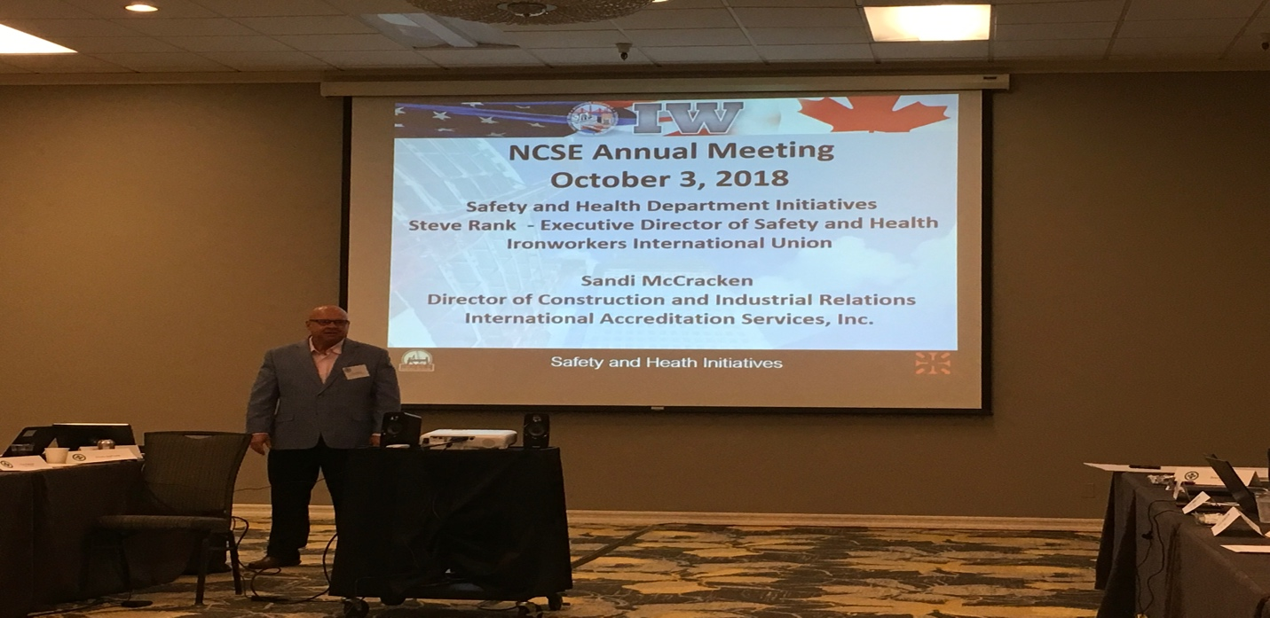

Steve – Zero Incident Campaign – Deadly dozen hazards. Falls through unprotected / inadequate floor hole coverings, structural collapse of unsecured joists, lack of fall protection or inadequate use, falls during installation of floor and roofing decking, material handling – offloading trucks, shop and reinforcing steel activities, shifting loads (chains removed before qualified rigger has a chance to inspect), column collapse due to anchor bolt failure / insufficient concrete strength, structural collapse of reinforcing steel columns, walls and decks, struck by injuries from equipment, falling objects, tools and materials, caught between injuries during hoisting and rigging, impalement from unprotected reinforcing dowels, heat illness / toxic chemical exposure, power line electrocutions.

Ironworker safety director training course – train ironworkers to be safety directors. 40 hour course. 10 subject matter experts provide this training. 450 iron workers have completed this training. Ironworkers have a card that you can scan that pulls up all training records for their union members. Can see who has been trained in what. They want us to ask for these training records. Designed for safety directors for any type of iron working contractor – steel erection, reinforcing, precast, etc… These are ironworkers who volunteer and step forward to take on a safety role. This is a first step, need to look at continuous learning. Contractors may choose to have an ironworker safety director. We could require that they have an ironworker safety director. Ask union to establish expectation that they have a specific number of safety directors per number of workers. Negotiate contracts – we can put in that we require a safety director. Full time competent safety director.

Ironworkers Safety Supervisor Course – Training for industry specific supervisors of ironworkers. Will be offered at all 157 training centers in North America. Train them on biggest hazards for industry – foremen, superintendents, etc… Coming to them from the General President of the union. From the time iron shows up on flatbed to demon. Every supervisor, I need a foreman from hall, that person will have training like this (in the future). Ironworkers are part of greater trades union – other trades are not yet doing a deep dive. They share what they are doing at general presidents meeting of unions, but others are not following suit yet.

Iron worker safety supervisor program is in pilot mode in CA. They are trying to understand the assessment process right now for the accreditation. In the future we will be able to request these safety supervisor trained workers, If you are signatory and you have direct ironworker hire. The safety director has been designated as competent person and other ironworkers are expected to listen to them. Just as they are expected to listen to Supts. Pay scale, how does the union look at the position? Up to employer – do they want to hire them as part of the gang or separate individual…safety director is full time safety (project safety director) Supervisor is foreman, supts, etc... When we require a designated safety person per certain # ironworkers, we can require this.

McCarthy was struggling with ironworkers at site. Contractor brought in Kenny, ironworker who was experienced from the field that turned to safety. He was a great buffer, worked seamlessly with McCarthy and owner expectations. Really worked well, became a model project.

Question for foreman / supts…Do you know you are a company management representative, not union foreman? They need to recognize they are the first line supervisor according to the administrative law judge.

Supervisors will be required to take this training, just like journeyman training. Safety director training is optional for those who want to step up.

Door is open if signatory company safety persons would like to attend the safety director training at no charge.

– Accreditation-Certification Program – Sandi McCracken Director of Construction and Industrial Relations International Accreditation Services, Inc. ICC / IAS

Fully owned subsidiary of the international code council – 64,000 members code officials.

Accredit ISO auditors who certify us under 9000, 14001, etc…. IAS will be accrediting the ironworker training, certification process, and curriculum development. Will work together with IWI to continually improve Safety Supervisor training. Steve Rank – ask each of us to assign someone to attend this training to evaluate and provide feedback.

Fall protection – training structure – Local 84-135. 2 story training structure / cantilevered canopy for training purposes. By the time they get done erecting this structure, they will use every type of fall protection currently available. These training structures are popping up all over the country – IWI is providing drawings for the whole process, start with shake out, erect, etc… as part of training. Aligned themselves with 3M, get discounts on fall protection for members. Could we partner with IW in our areas to help them get this training structure if they don’t have it?

Voluntary air sampling initiative – Heath initiative. Manganese threshold from .20 to .02 for welding. Only two ways to protect workers = articulating method to capture at the source, or respiratory protection. Steve provided us air sampling CDs with air sampling reports for welding. Can use as historical data.

New rebar standards – over 55% of IW hours come from reinforcing. New ANSI standards passed and reaffirmed, some states are accepting these in state OSHA requirements.

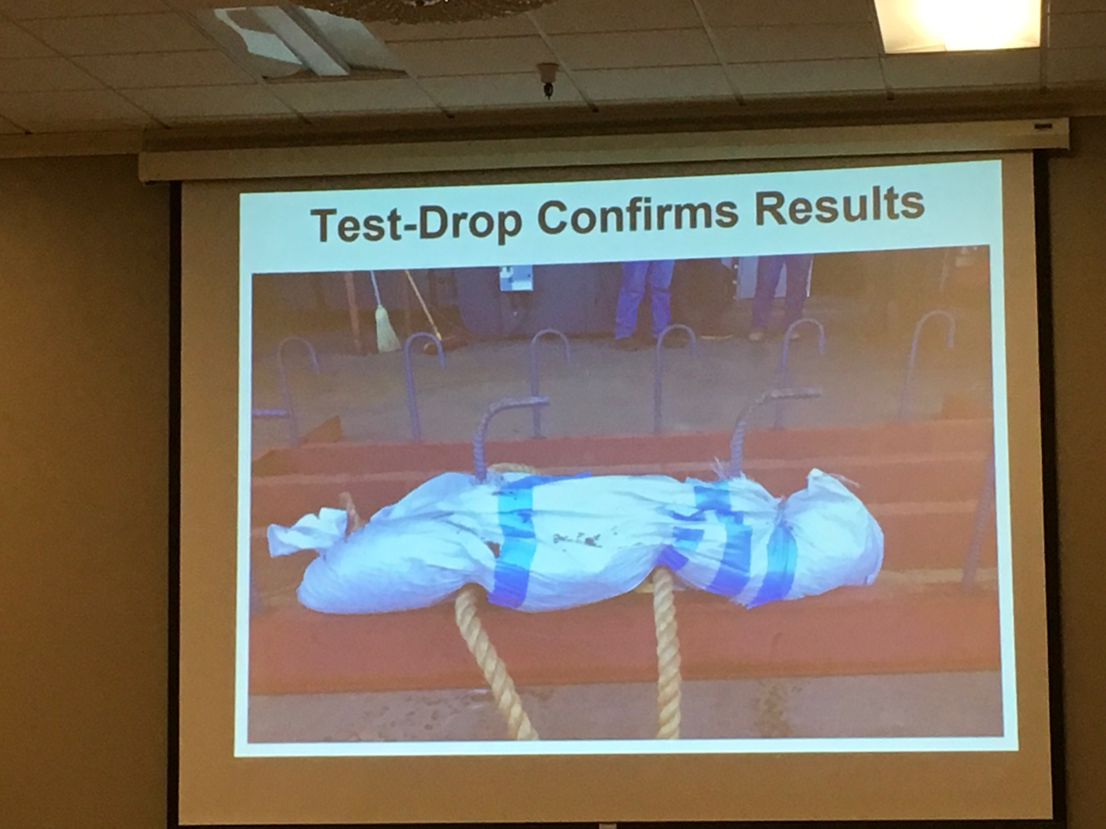
Impalement – 220 lb bag of sand, dropped from 10 feet. Question brought up regarding candy cane OK for slips and trips from same level?

Need to make sure we have the right protection or the hazard.

Compliance directive exists saying that if employer provides 100% fall protection it is only a deminimis violation if you do not deck every two floors. Circumvents final rule that says you had to deck. Contractors are giving compliance directive to GCs saying it is OK not to deck. 2 related fatalities.

Shear studs – compliance directive there as well. Make sure we are following final written rule. Related fatalities with these too. Tripping hazard exists, regardless of directive. Causing falls, people may not hit…but hit neck and caused paralysis.

11:00 AM LUNCH Atrium

12:00 PM Best Practices
- Dash boarding – Pre-work for Turner, Sundt, Kiewit, Mortenson, HP) Cindy DePrater
Sundt – Observations dashboard – severity / risk rating. Mobile frame is the software that Sundt uses. They built their own. They write their own code. Currently rating does not trigger any events. 18K observations. Currently have 1 BD resource helping with Power BI

Turner – Risk Console / Predictive Solutions / Vue / SAP – hours from SAP, hours from Vue, hopefully all of the information ends up in Risk Console. 2 full time analysts in Risk, IT resource and Cindy’s assistant help to maintain valid data. Subs put work hours in online systems, as do project sites. Break down by trade partner, break down by nature, causes, body part. Rates by CCIP, OCIP, Corporate, etc… Took about 5 years to be comfortable with data credibility. When CCIP is higher than others, you have a good indication that you are not hearing everything. Agency CM they capture data but do not mix with additional Turner data as they are not in control of data and do not trust data as much. Connection to insurance partners, data feeds in on daily basis. Shows what they are inspecting the most and where their injury trends / near misses are the highest – indicates they need to redirect inspection efforts to other topics. Procurement uses information to make buying decisions. Can look at which subs are having incidents, and which are being performed. Can look at what is being inspected again to make sure they are focusing on the right thing. Subs are not entering information in order to control data integrity. Predictive solutions can tell her if her individuals are falling into the right range of inspections in terms of % safe.

Hensel Phelps – Gold Report – uses Power BI. Leadership involvement, employee engagement, accountability –Violation notices people have on mobile app? Vista is new system they are using for man hours (HP). Give feedback button – Anthony – Industry Safe / AIC are common platforms – what is HP using? HP has a self built platform. Mobile version is tailored to show only info that would be useful in the field – violations notices for example. All HP employees have access to this information. Some security settings – financials / individual incident experience is limited to GS and above.

Brasfield & Gorrie – Fed by app on their phone. Poor mans version of Dr. Pettinger – had data that is going nowhere. Dashboards set up regionally. The most effective way they are using it, people want to know how they are comparing to other regions. Project scores, subs with most deficiencies. Tying loss runs into this for understanding. Input for safety deficiencies are put in through app. Used to start a conversation. What is our current status, how could I get better? Score crew work plans, housekeeping, incident management, PM / Supt audit, weekly safety meetings.

AE COM – you tell us who you want to do senior management observations, then you have to meet 90% of it. Change leading metrics annually. First year all of the leading metrics are green, but lagging are not…gaming system…upping their game for next year. Stoplight chart gets a lot of visibility each month. Reviewed by CEO and business unit leader each month at start of financial reports. Started tracking training, anything you put on there gets done due to visibility. Measure Individuals which is wrapped into comp / rewards – senior management expectations, etc…. Sr. Mgmt observation was red for a long time, took them time to get up to speed. Safety was the first to have leading indicators, now quality and safety. Lifeguard software system / JV with Sundt. At the end of a period, this takes 2 weeks to pull together. Which leading indicator are we getting the most juice for the squeeze. Board of directors / what are we looking at?

Black and Veatch – has safety and non safety leading indicators in assessment. Tim to share list.
Safety is only one piece of the puzzle, assessment indicates concerns. Teams getting along?

1:00 PM Best Practice Showcase- 20 minutes Each
- Vertical Reinforcing Steel Elements Justin Walz, Sundt
- Communication Chris Bartku, AE COM
- Imported from Detroit-Life at GM Brad Barber, GM

Sundt - Best Practice Sharing – Vertical reinforcing steel – Fatality in San Diego several years ago.
- Reinforcing Steel strength or weakness – Bracing plan? Not verbal, don’t just trust. Sundt now has a policy on reinforcing steel bracing. Failed boundary element, column, formed column – removed brace for space purposes and column collapsed, rebar column 100% tied and braced…but bracing was not engineered and was not secured per plan. Industry initiatives =ANSI 2013 standard gave definition to concrete and masonry work “collapse” definition. 2014 Cal OSHA addressed stakeholder concerns and in 2015 they adopted the ANSI A10.9 standard. New trend to structural designs – Structural engineer designs are moving from large vertical members and small horizontal to smaller vertical with larger horizontal to allow for movement. Loads of reinforcing cages – Self weight, construction loads, Environmental (wind).
- Example – a 24 x 48x33 column with 18 #8 and #5 ties at 4” - if column is 2% out of plumb or roughly 8”, bracing plan must be designed to resist 3520 lbs-ft. Not a lot of engineers are looking at this, there are two companies that they have found that have spreadsheets that you can pop information into to get this information. Innova. Construction load – worker climbing in 45 mph wind = bracing plan must be designed to resist 9000+, WIND – 28th floor at 75 mph wind = 18000+ lbs. If column form is hung it is at 24000+ for design requirements. Internal bracing better than external, external can be removed and there is always limited space on deck. X-bracing as an example to keep columns plumb. Sample project – 6 out of 10 column designs would not have supported people. Sundt best practice State stamped PE. OSHA says competent person…not legal requirement to have these engineered / reviewed. Contract language has been changed to require engineered bracing plan. Must follow manufacturer installation methods for braces? Engineer will spec how the brace must be installed. We need to inspect to the plan. 2x4 and turnbuckle might be sufficient still, but need to have engineer review to verify. Need to look at deck and what is able to be supported, may need to penetrate deck / get deadman block. Engineered plan required, will not be modified unless specifically addressed in plan, verify that they are following. PAUL to share vertical reinforcing steel elements. A few thousand for engineer to do this. Charge by column design changes.

- Chris Bartku – AECOM - Ideas in Safety Communications – Culture of Caring video – AED / saved a life. Video series. More runway with videos. Life Preserving Principles. (CII study Zero Incident Techniques) Safety for Life. Live preserving principle of incident investigation. Share incident, lessons learned, action plan. 1 page weekly communication – click through counts – only about 20 to 25% click rate…good but not what we want. 1 minute pod casts. Tick check time video – like the CDC says. Field Biologicals. Tishman orientation / immersive technology group. Google suite / sketch up. VR is mainstream now. Safety for life news network – SFLNN Pilot Episode (YouTube). Leverage early career professionals who are interested in building these things, give them a task code, etc…

- Brad Barber – Construction / engineering to manufacturing. Differences in role? Every person, every site, every day. Had focused on construction, but had not focused on suppliers, odd job safety = 85,000 persons. Global, 70 languages, vision = zero crashes, zero emissions, zero congestion. How they work in manufacturing vs. autonomous world, etc… Goal of 20 EV by 2023. Safety is still safety – Many similar challenges. Help company look at things differently, not bogged down in details of differences. Each country had their own way of doing safety. Not contractors, people. Focus on all people, not GM employees only. Expected GM would have great systems in place, turns out Parsons had better systems. I have met the enemy and it is us….lack of consistency, communication, process, looked for outside help in part for this reason. First time he walked into assembly site, shorts, just above flip flops, no safety glasses, tank tops, Rap, outlaw country…on their phone, etc…. No wonder they were hurting the people they did. Not a year that they haven’t had an employee die. RIR is 1.7….if your rate is 4.0 here, South America might be a little higher, China = no injuries, just disabling injuries and fatalities. Brad reports to 40 year veteran who reports to CEO and has no safety background but knows ins and outs and knows how to get things done. This relationship is very collaborative. Reduce injuries by 20%, no disabling injuries or fatalities. Do it today, do it tomorrow, do it next week..zero injuries is not a goal, it is a decision. Employee engagement, trust of frontline supervisors, etc… has been an eye opening discussion for them. Brad now has a meeting with Ford, Chrysler, etc… information sharing. More resources at Parsons than there are at GM for safety. Frontline supervisors / salaried are responsible. Rotation of maintenance superintendents, engineers, etc…can be a challenge or opportunity. High potentials rotating through now. Work comp – self insured / sedgwick – they had no idea of loss at plant level. Unions have an impact on decisions / abilities. Culture, knowledge, systems, data, risk mitigation – road to zero injuries. Be bold, one team, it’s on me, win with integrity, look ahead, innovate now, think customer. They have very few SVPs. Not a lot of VPs. Manufacturing globally, risk, all non manufacturing globally, IH, Training all falls under Brad….Executive Director. Real Estate, Facilities, manufacturing / engineering. They do their own maintenance, but much of their work is subcontractors / Aramark services. Marketing challenges – banners, helicopters…. ME group joint effort to do better. UAW contributes safety people, some really get it and help. Some may need to choose other careers if they inhibit progress.

2:00 PM BREAK
2:15 PM What Are You Presenting in the Boardroom/ Executive Leadership/
Senior leadership – (pre-work – come prepared to discuss) DePrater / Levin facilitate
Sundt – board reviews stats. Year over Year +/- for the benefit of those who are not safety focused. Housekeeping focus, safety focus, etc…
Quanta – reports to CEO. Board mentor – helps understand what Board wants to review….reviews slide. Has been 30 min presentation. Now every other meeting (quarterly meetings) are 1 to 1.5 hour deep dives. Want to know proactive measures they are taking. Have not had environmental focus, now it is a tab in their book.
AECOM – Andy reports to Chief Legal Council – Performance year over year has been good, which equates to less budget. Had to lay off 9 people. When engineering firms try to do construction, don’t do well…lose margin. Board is pressured as stock is stagnant. New approach – enterprise risk management. Top 20 risks, top 10 get boiled to top. Safety is and should be one. What really makes a difference, what could create concern in the board room without losing his job.
- Unmanaged contractor performance exposing AECOM to risk of brand, customer concern, third party…. They have walked off two international jobs where customer didn’t support providing safe worksite.
- CM at risk projects
- Driving – India, Saudi, etc…
- Environmental
- Statutory safety by design – failure to meet requirements
- Failure to implement program – AECOM takes over contracts from incumbents who have had contracts for 10 years or more…Afghanistan, Korea, etc….take over work, employees, etc…. One day they are one Company, the next day they are AECOM. Safety can become a priority vs. a value as managers try to get arms around things underway.
- Self performed construction – impact of score in ISNetworld – customers who won’t work with you.
- Working in remote areas / high risk environment
Andy meets with board 15 minutes per year. Carla carries message area every quarter. #1 engineering firm, 90K employees.

Brad / GM – Board meets 6 times per year. Tended to be bad news report. Now start with Safety Moment…Mary (CEO) usually provides it…they provide content. Every other meeting, there is a risk committee meeting headed by Admiral, ex-oil & gas CEO. Talk about one of their “wedges”. Talk about high risk areas (currently contractor management). Preread – 2 or 3 pages. 1 slide. 10 minute presentation by Jim, Brad’s boss. Risk Committee meets every other time and others have been sitting in. When Brad’s boss was put in place, he scheduled a 1 on 1 meeting with members of the risk committee. Listened to their concerns, help drive direction.

Zachary – Don reports to Steve who reports to a board member. They meet quarterly – Steve Brower (board member Steve trickel reports to) meets quarterly with John Zachary and presidents of business lines. Projects have changed drastically in size. Typical job, 95% of people are direct hire. Zachary folklore…be careful how you handle subs so that you don’t take on liability…working through that.

Granite – Public, 2 former Skanska CEOs, Oil and Gas CEOs. They prep Jim to present to the board. Jim tells them what to prepare. The board is more active now than used to be. After last meeting they sent a message to 4 business unit requesting recovery plan. Jim and CFO go every time, occasionally invite senior leaders. Quarterly face to face / monthly calls. 40 people or so. Before he was able to present anything, Jim gives him topics. Dave tries to sneak in extra slides.

McCarthy – reports to COO. Meets with him weekly. He reports out to leaders regularly, Kevin picks a topic and reports out, then they fire back to him. He sends out a monthly report. Regional guys send out updates as well.

HP – Talk about stats, jobs that are not hitting the metrics, Jerry recognized that Board didn’t understand what safety directors did. Now safety directors meet with them twice per year – spring…what are we focusing on this year (3 or 4 things), Fall – what have we accomplished.

HDR – senior management observations by name every month, training needs based on risks, utilize statistics in productive way to get what you need. Employee survey – 94% of employees thought HDR cares about safety. That blew them away, now he gets a one hour presentation (topic scrutinized). All in the approach.

Quanta – one of the board members is a safety director. She reviews slides and gives him questions to ask.

Parsons – Tough to gain ground during board meeting – one year of initiatives in 15 minutes. Schedule one on one time with presidents.

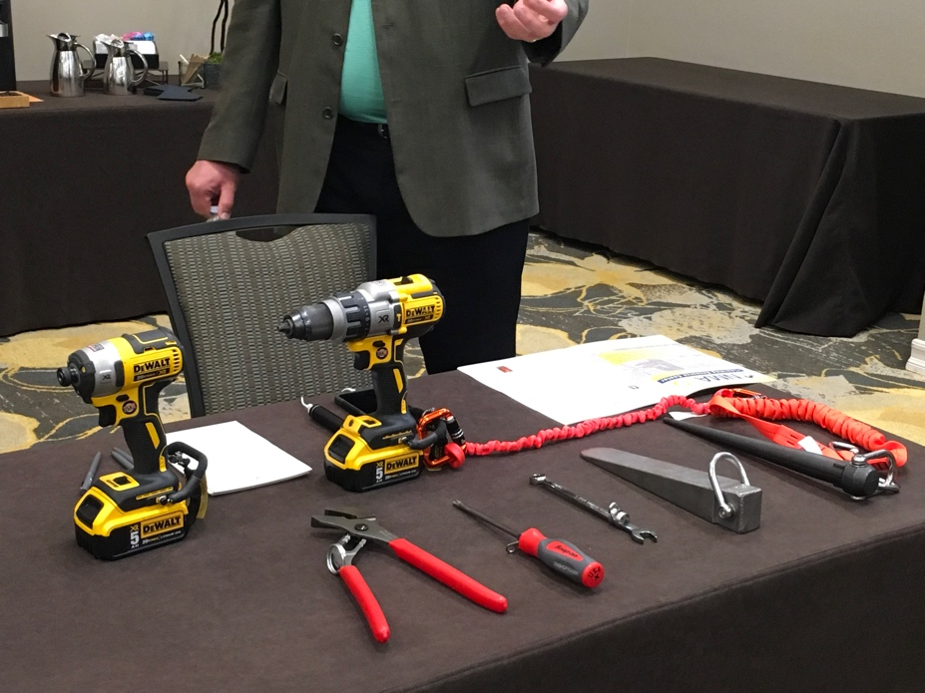(See close up photos of DeWalt tools below)

3:15 Dropped Object Prevention Rusty Brown, Kiewit
Currently DeWalt and Snap-on are the ones willing to play ball. Millions of dollars into improving drop prevention tool connections. Snap on developed tools for NASA with tethers. Willing to retool their lines to produce these more widely, need us to promote these so we collectively are buying enough. DeWalt has a push to get rid of corded tools as well. Tool tape was the only solution for some tools. Addition of anchors and tapes = $$. Kiewit spent $3M on tethers last year. Now manufacturers are taking ownership and responsibility for anchor points and incorporating in. DeWalt, 3D printed prototypes as they sat there. New 20V tools – 30 min continuous use with grinder, charge quickly. Testing phase – took to craft to get feedback. If tool is subjected to a drop, red spring will expand out, indicate that they could fail. Kiewit marketplace – similar to Amazon. Remove tools without tethers. Subcontract requires them to have drop tool prevention…guide to help them. Rusty to share drop prevention supplement.

Kiewit considering getting rid of all tools without internal tie off options. Trade partners are required to tie them off, internal not required.

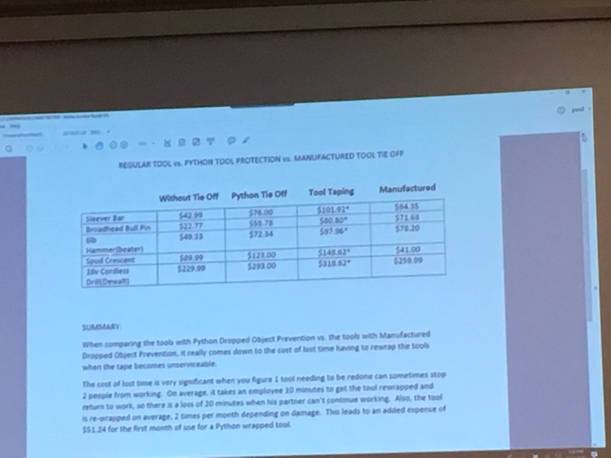

3:45 PM Recap of day and introduction to Darnell dinner and drinks Paul Levin
4:00 PM ADJOURN
5:00 PM Darnell Dinner and Drinks: Presidential Suite Members only
7:30 PM NCSE Group Dinner Members & Guests

THURSDAY, October 4th Pinot Noir Conference Room
8:00 AM Welcome and Agenda Paul Levin
8:10 AM Safety Moment Eric Grundke, Kiewit
Fall Protection – Kiewit – Setting bridge beams. 2 ft girder stop, above top of cap that he was walking on. Engineered drop in anchor point. Flying last beam in, rebar sticking up needs to mesh with studs on beam. Walter was using a 4x4 to pry them apart. Wearing DBI Sala standard nanolock. Currently working through forensics of nanolock, lot of tool. Pendulum effect caused nylon to rub across concrete, anchorage point loading transferred to edge contact point causing nylon to cut. Champfered edge. 3M is putting together videos to show importance of shock absorber in right place, sharp edge, etc…. Above D ring or below d ring tie off – greater force, fall distance, etc…

Nanolock was used within written guidelines. Sharp edge, leading edge equipment will be marked as such. Don: ANSI standard has not come out for leading edge / sharp edge. Manufacturers are selling things, but the committee is still working on the standard. Overhead anchorage points – difference between feasibility and convenience. Knee jerk reaction – they were going to go to all one type of equipment and that is it. Instead, they are revisiting hierarchy of controls. If you are relying on PPE for falls, the plan has to go to the General Supt or Project Supt. If you are unable to find an overhead anchorage, below the d ring tie off, you have to get offsite supervisor approval. Aluminum vs. steel hooks. Aluminum hooks will bend when side loaded, could fail and come loose. GM still had a bunch of light weight hasps – seems like they are eliminated in construction. Kiewit has been able to break cable and webbing, but cable may not have cut due to placement of shock absorber. 2 leading edge sharp edge retractable that they are allowing. Cast in place inserts with bars for tie off as suggestion to get overhead anchor. Kiewit is going to all sharp edge nanolock. They are specifying a few different harnesses to go along with heavier nanolock, including backpack style with frame to support load. 3M videos will be distributed once available.
8:30 AM Darnell Roundtable Recap (from Darnell Drinks and Dinner) Executive Team
Data Management
CMO – Kietrac, Power BI, Tableau (Kiewit). Lots of data collected, best way to get it usable. – Permissions built out.
Dashboards – those who presented, clean them up and clear out personal information so that we can send out and share.

Leading indicators

Orientations – field orientations. Current processes allow workers to tune out, how many orientations have people been through. Must have test to hold attention. CEO / COO message. Focus 4. 1 hour class / 1 hour field. Mentor. Kiewit – craft ownership / engagement in orientation. CVIS involved in all orientations (even when they are on tools…) to at least explain process and what they do.

Culture – Senior leaders demonstrate. Need to be able to articulate the vision that culture is at home and at work, is seamless, is not in competition with production or quality. Leadership drives culture, there can be subcultures. Culture has to be communicated in orientation and supported by leading indicators / recognition. Brad – don’t believe in safety culture. We have an organizational culture which Safety is a part of. Otherwise safety becomes a bolt on.

9:30 AM Business Meeting Paul Levin/Executive team
- Charter and Bylaws review
  - Guest attendance and participation
                - NCSE logo
- Membership discussion/Actively review roster
  - Brent Landry – Bechtel
Shiny objects, pizza lunches / apples at the gate – what works in one company might not work in another. Repeat incidents associated with established standards. 90 minute meeting…5 min on don’t put a frozen turkey in oil….the next 85 min beating them over the head with schedule. What are we really telling them? Bechtel takes account for all JV stats. Trying to bring forward relationship with Health. ISOS, medical manager, doctors on some sites. 4 year plan, step change improvement – move from compliance based to risk based management system. Refresh core processes, revisit assessment tool to assess risk and leadership. Enterprise certification to ISO 14001 / 45001. Broader view of occupational health, wellness and health in design. 3 of 4 had 180001, moving to enterprise level. Started in field, worked way through Safety ranks with maintenance contractor, Bechtel subsidiary, Bechtel. Leadership drives performance – EHS need to demonstrate same leadership we are looking for from the frontline.

Brent Landry – accepted as member.

  - Potential Candidates- STV, Weeks Marine, Allan Myers, Walsh, Barnard
Dave Klewinski – STV – present company – meet minimum criteria?
Allan Myers – Paul Ziegler
Weeks Marine – Mike Pickerel
Walsh – Jack Brazil
Barnard – Mike Flynn

Ames
Wood
Michels
Suffolk
Gilbane

Voted on moving individuals to emeritus / honorary.

Voted on gear logo. – Eric Zuhlke to send to Jerry.

Charter / bylaws – keep visitor costs the same.

April 2nd and 4th 2019 – Phoenix
Fall 2019 – tentative first week for October
Spring 2020 – DC
Fall of 2020 – Denver wins

Austin
St. Lous
Chicago
Detroit
Denver

                - Selection of next meeting locations
                - Topics for next meeting
- Industry Updates – BCSP and Cranes Brad Giles / Dick Thompson
Brad Giles – updates on ASSP / BCSP. ASSP – name change in effect in June. New Executive Director / CEO – Jennifer Mc…, Tom Kurser account executive. Revenue has been flatlined at $18M. Pushing to reach $25M. Not for profit, but it is to advocate for profession. Process to help companies get to accreditation 450001. Recognition for Companies and Emerging Professionals – getting voted on today. Executive coach, leadership opportunity, free PDC participation. Executive forum – 30 individuals across 6 industries – started last year – lead safety with CEO. Next one scheduled for November 8th. Speaker = Tom Kraus.

BCSP – ANSI just accredited all certifications. Individuals who will go to Company meetings. Will do Group tests. Transitional safety professional – recognition for US ARMY combat center (can get that title, then move on to CSP similar to GSP). $300,000 in scholarships.

BCSP / ASSP / AIHA working together to get safety into high schools. Need 4000 new safety pros per year across the country. Try to get people to select this as a profession. All of these websites have salary survey available for 2018.

NCCCO – Improving safety in the workplace. ANSI accredited program. You can help us help you. Mentors now provided for practical exam audits. Failed examiners can get into probationary status or removed from program. Program Integrity Team separate from Ethics and Discipline committee. Tools for us – Tool #1 = Report unethical behavior. Report that you don’t think someone should be in the crane. Integrity hotline 1-833-30-NCCCO. Call and report, they will act. Similar to OSHA, if we give identifying information – specific incidents, investigation results, concerns, identifying information, they can act more effectively. Tool # 2 = Verify CCO online. Verify there is a bogus card, send them the information. If a worker has re-certified they will have an R after their cert #.

Programintegrity@nccco.org

11:00 AM BREAK
11:15 AM 21st Century Helmets Anthony Romeo, Colony Hardware
Hard hat discussion – KASK, MSA, etc…. Turner doing helmet study with CDC and NIOSH. KASK joined study and is providing information. ANSI cents can be very confusing. What is approved and what is really approved?

Bridge gap between standard requirements and safety offerings. Consider evolution of gloves. Similar with glasses – foam lined, goggle style, etc.. Vests can have LEDs built in now. Head protection has not changed much. Each situation, depending on the conditions, requires the right PPE…including head protection. How common is Traumatic Brain Injuries in Construction? Niosh studies – Companies with less than 20 people were more than 2.5 times than larger companies with greater than 100 people die from a TBI. Roofs, ladders, scaffold…more of exposure. 2200 deaths from TBI between 2003 and 2010.
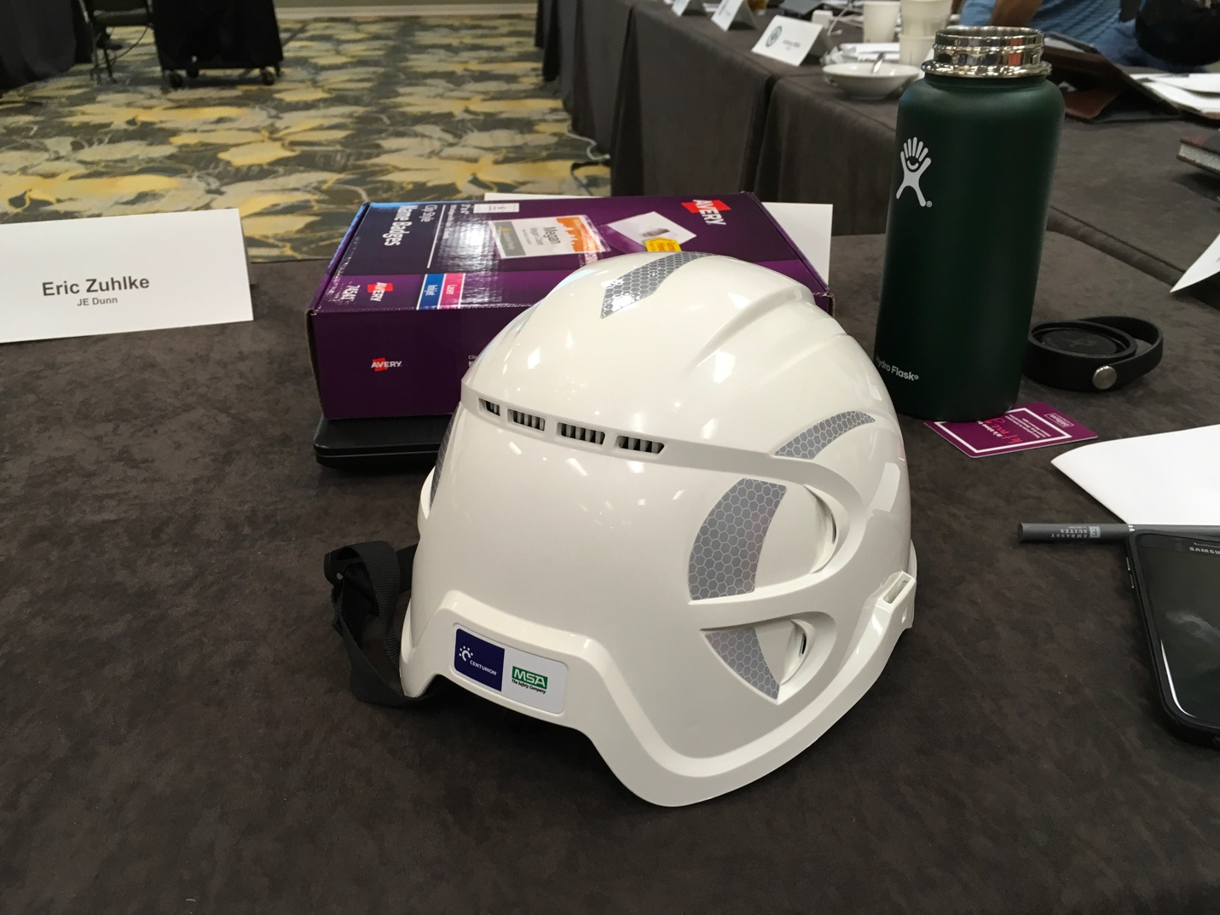
Fatal falls in 2016 134 of them were from the same level. Slips and trips are the most common cause of TBI. Fall, hard hat bumps off. Type 1 impact – top of head impact. Hard hats are tested for this. Type 2 has top of head and side impact. If it doesn’t pass side impact, it is not type 2. When people fall, often the hard hat falls off. Implement hard hat for the application. Type 1 hard hat. There are climbing style hard hats, can have chinstrap or not that are still type 1. MSA Without foam, about $70…with it $90. KASK = $130. KASK hard hat has a life of 10 years. Hard hats = 5 years and insert changed out annually. KASK hard hat = no suspension, just foam. Eliminates suspension which tends to make them bounce off. PIP, 4 point chinstrap, suspension is not attached…you can adjust it when you clip it on and help it fit better…stay on head better. Mid $30 range for PIP with glasses, mid $20 without.

12:00 PM Plus/ Delta DePrater
12:15 PM Wrap up and Adjourn
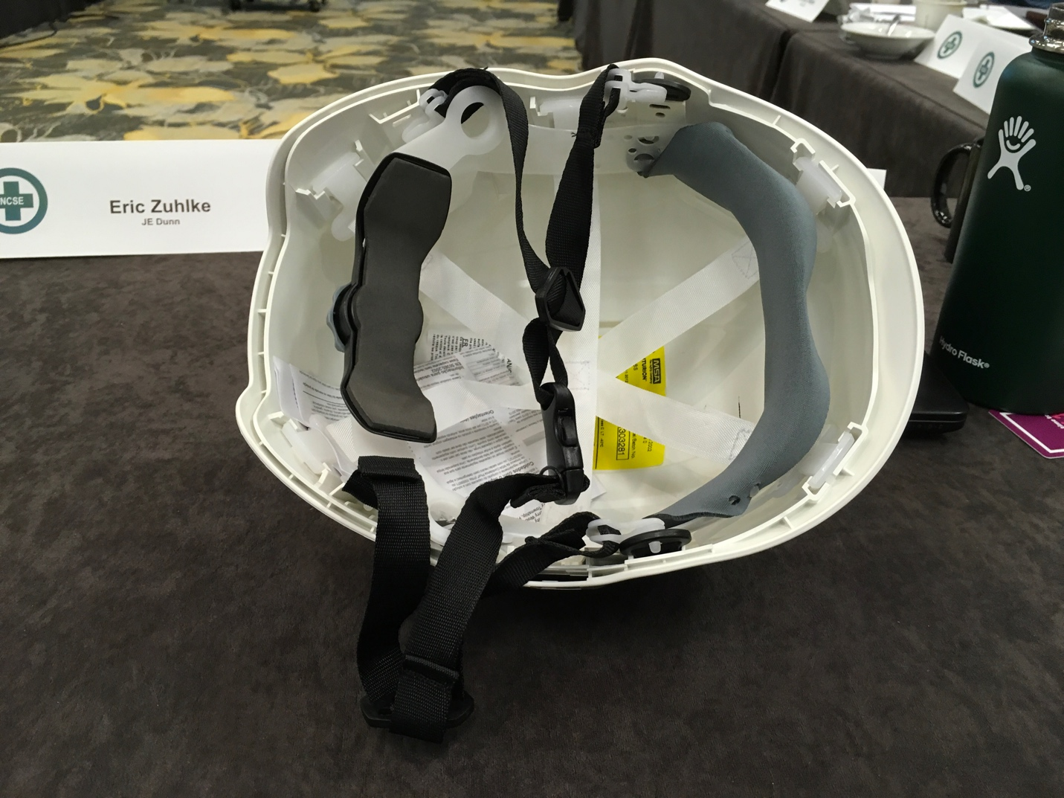

All hardhats shown except last (JSP) are type 1. Benefits of helmet style is that they stay on…not tested for additional impact protection. Entire concept is that this stays on your head. MSA is coming out with a different hard hats. KASK is changing our thinking on hard hats. Not certain about Canadian markings / requirements. Because there is no suspension, does the impact create a greater impact on the head? Manufacturers only tell you that it meets Type 1 requirements, won’t tell you if impact is greater or not. Consider glove ranges…can perform at top or bottom of range…still meets type requirement.

Regular chinstrap with V Guard…recoil is not as great, hard hat stays on, no different. Climbing helmet style, even without hard hat, stays on your head. Climbing style helmets, some come without chinstraps, must request. All different colors available. Four point chinstrap is more comfortable.

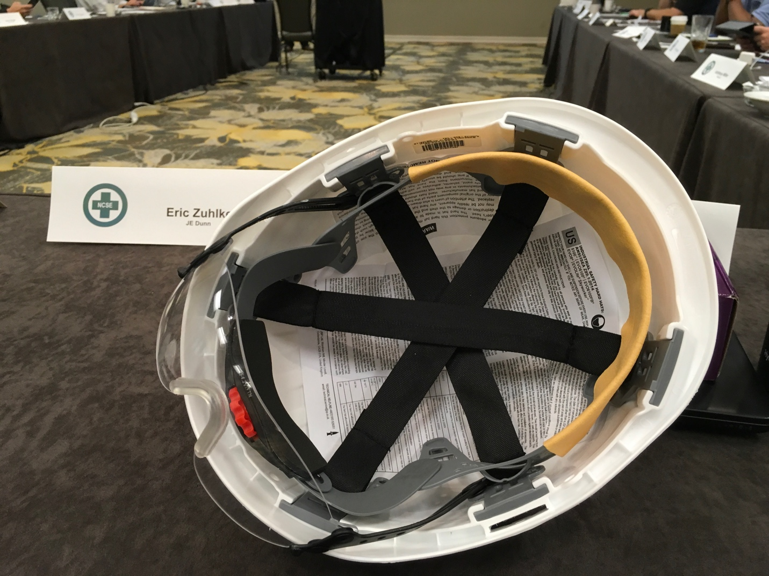
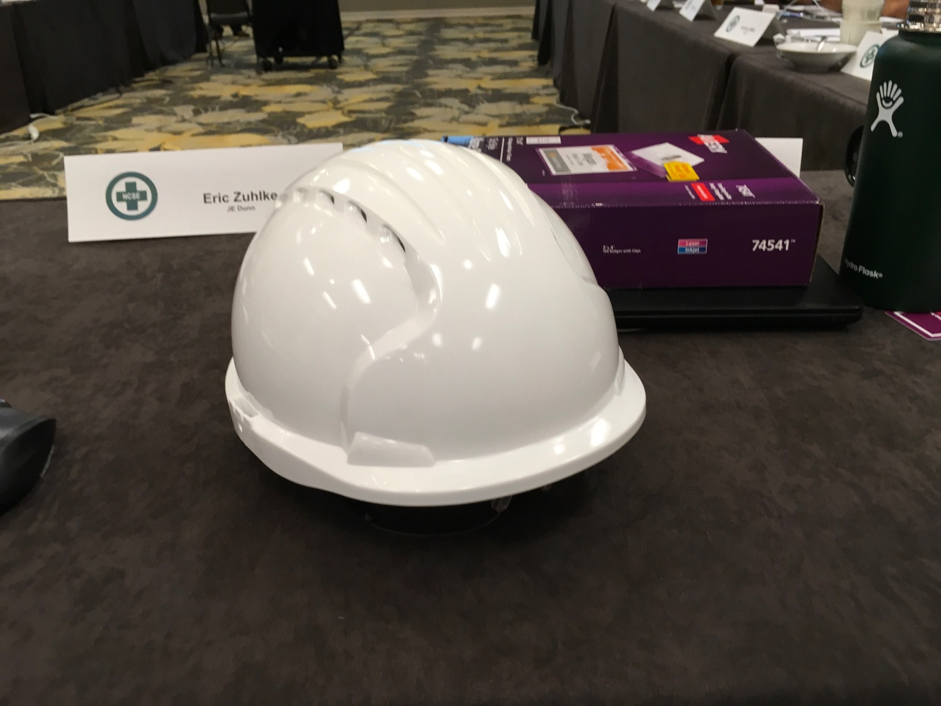
Skanska writing in contracts.

KASK has minimum of 50 to 100 to logo.

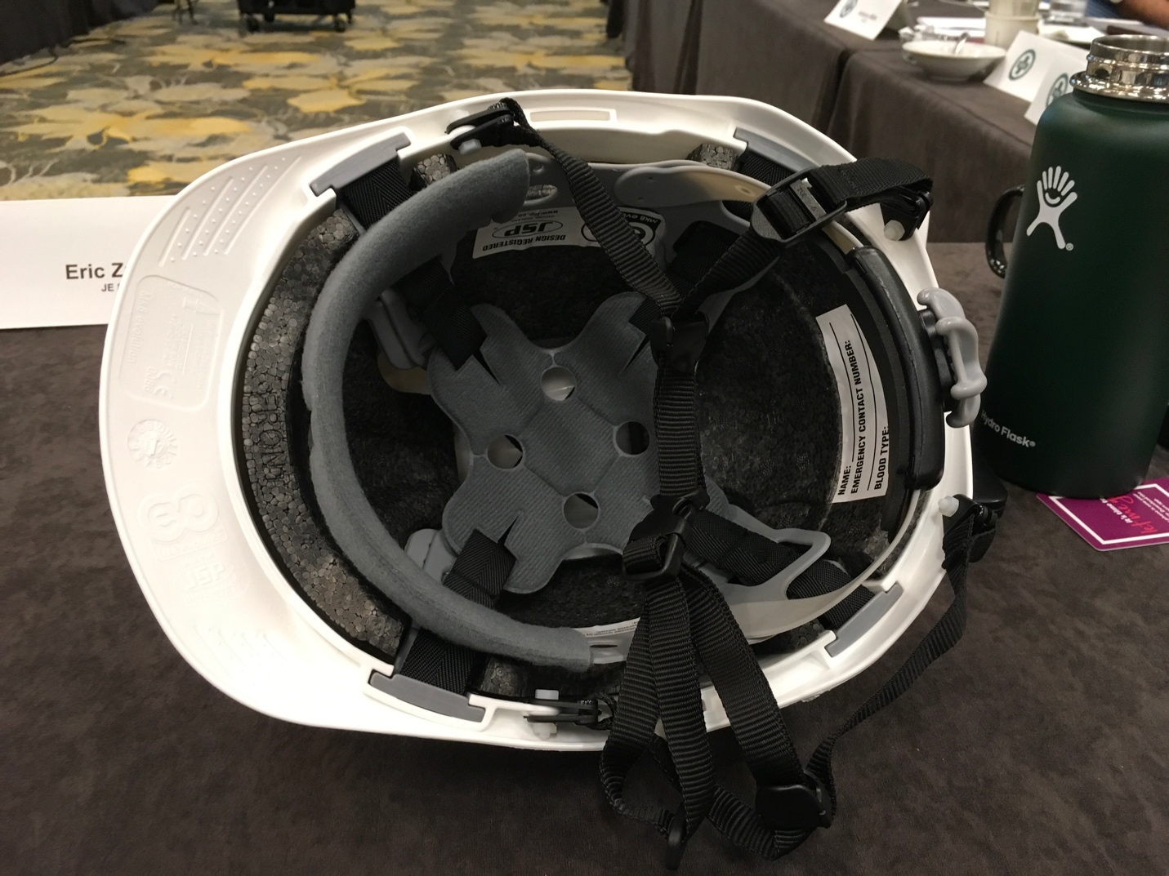
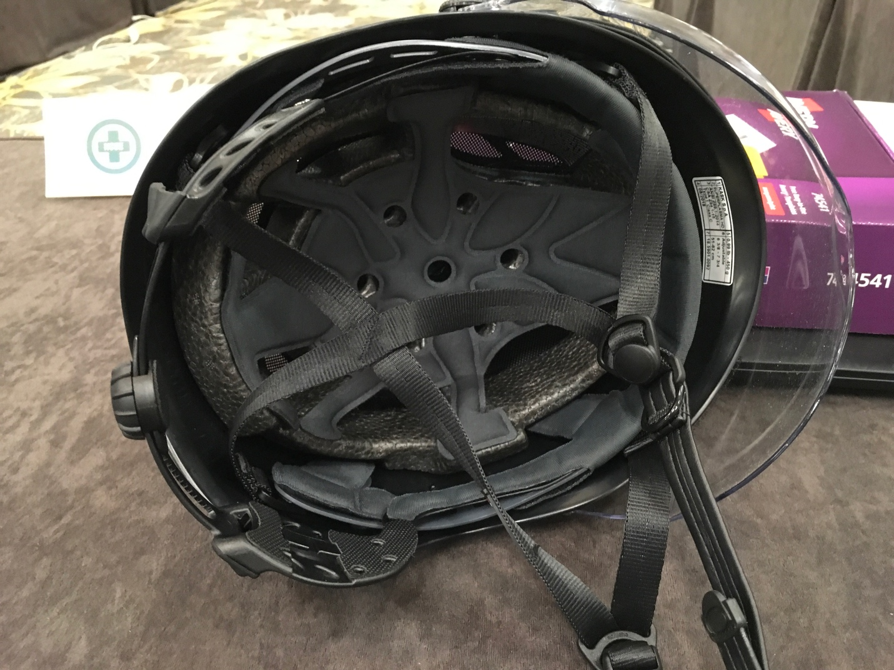
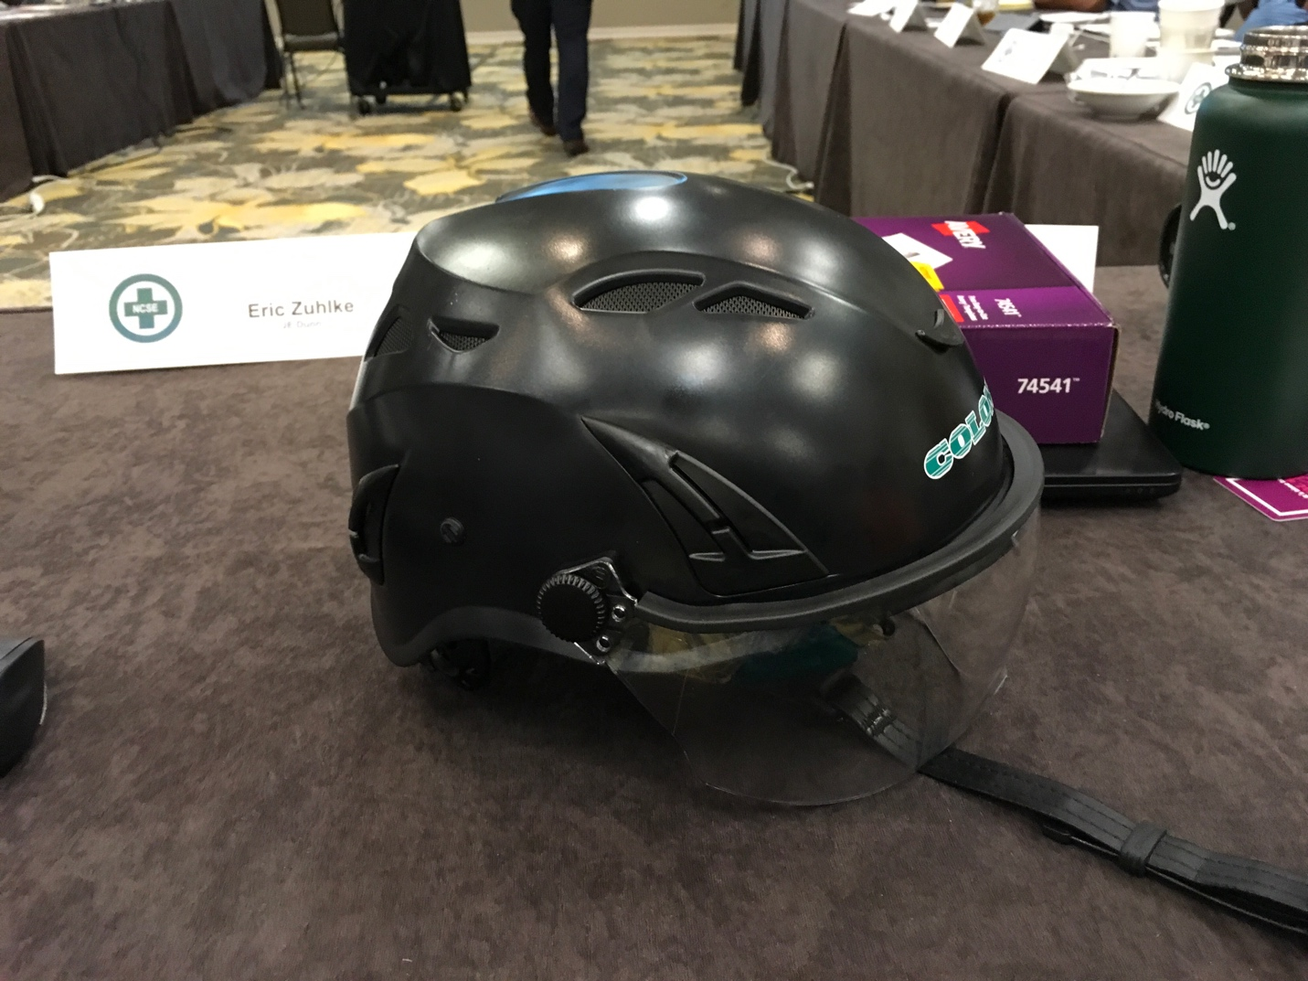
MSA just released their style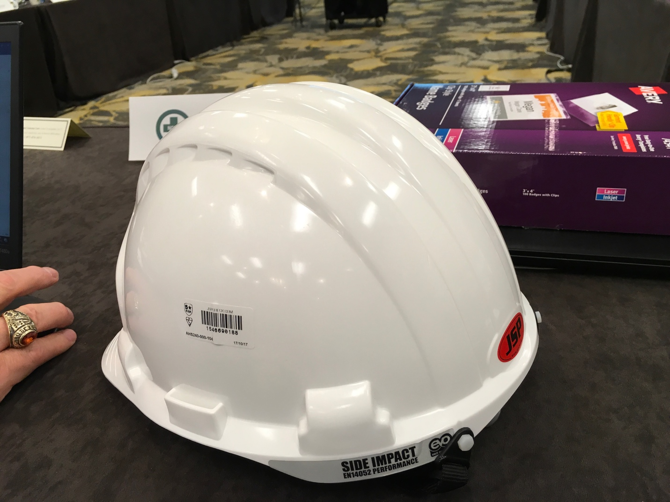.

12:00 PM Plus/ Delta DePrater

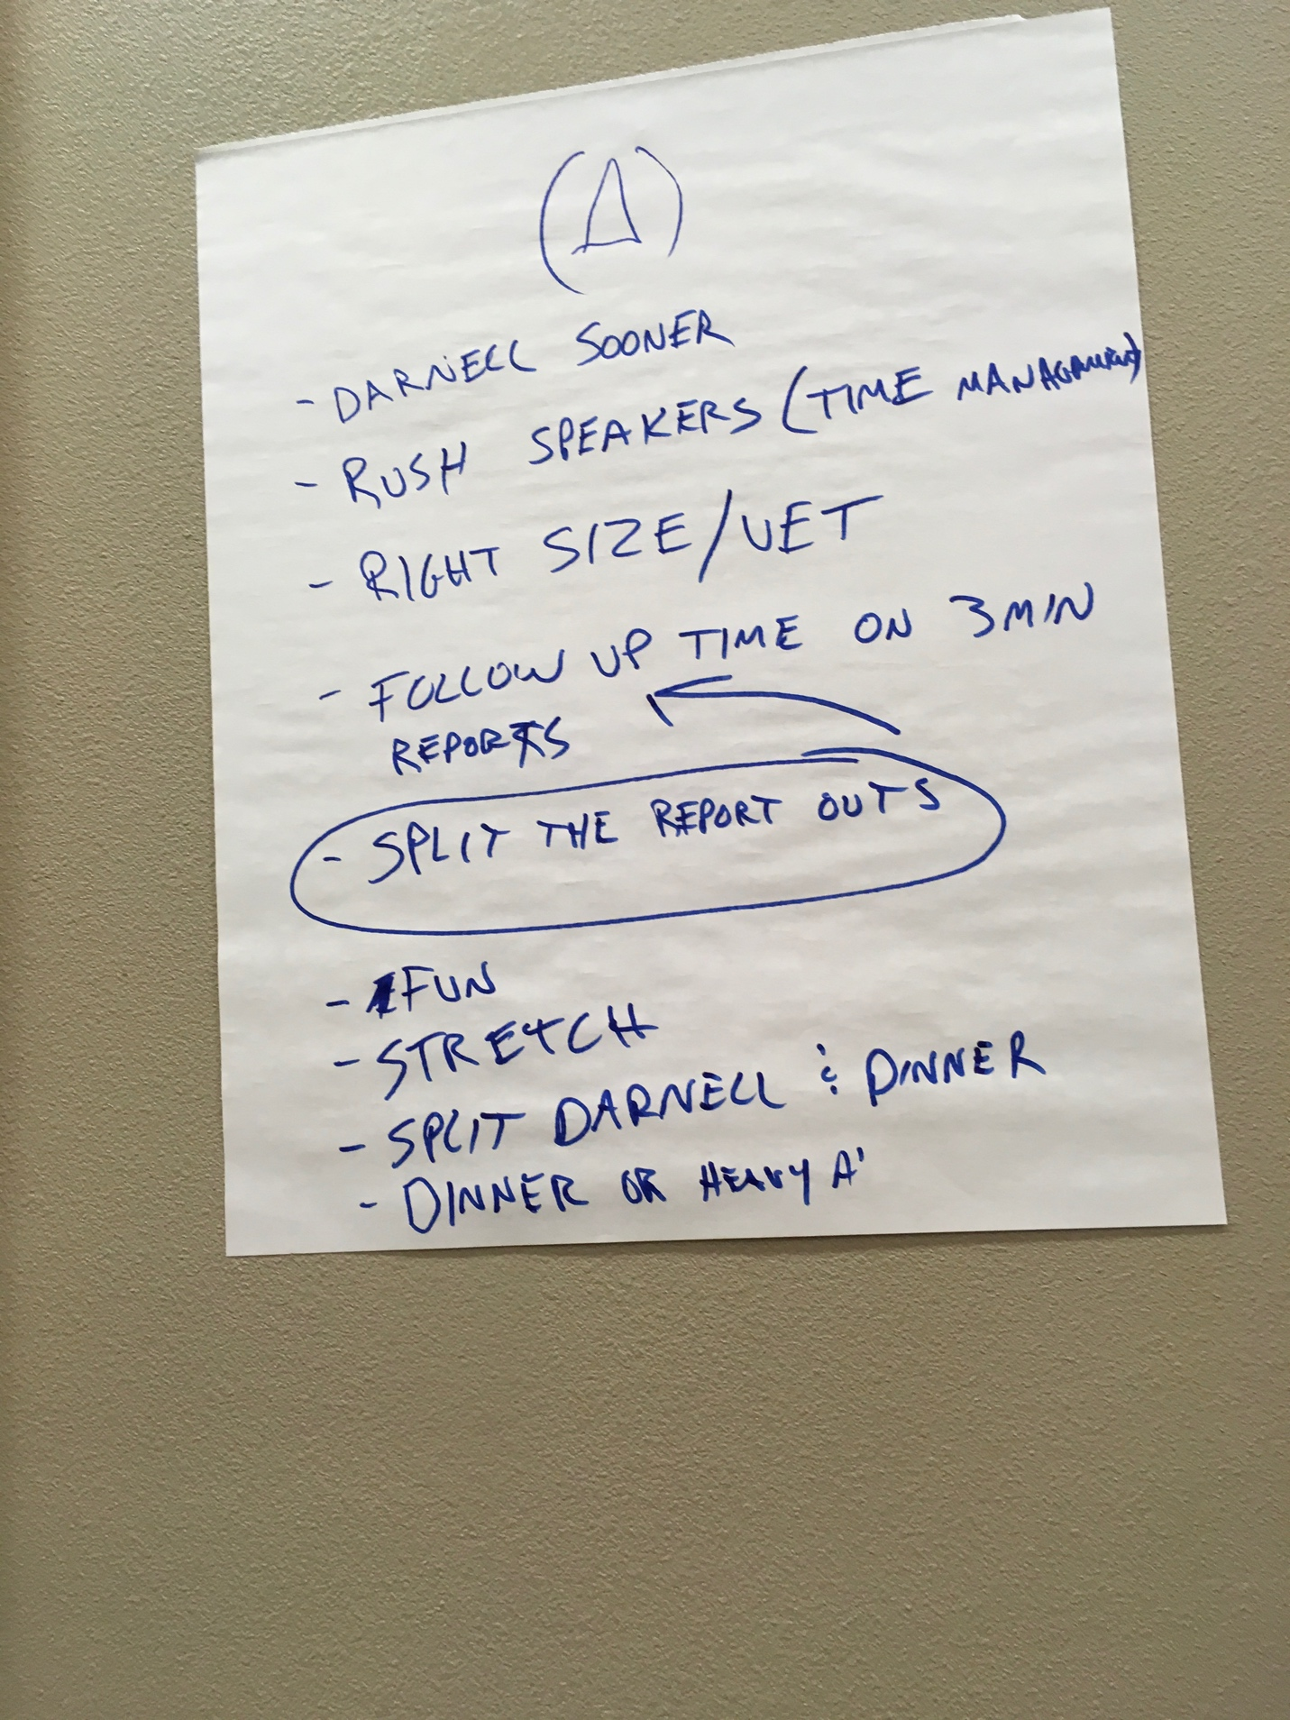

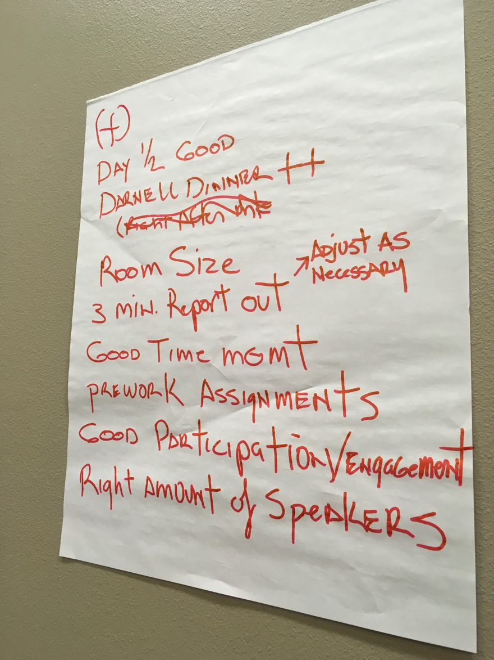
12:15 PM Wrap up and Adjourn

