NCSE
October 6, 2021
Kiewit – Alicia – Appreciated Covid information sharing in this group. So impressed with collaboration and email forum. Mental Health sharing – getting ready to revitalize / new campaign.
Jason Campbell – GLDD – Drastic move to mandate vaccines has worked out, leading others in dredging industry. Mental health sharing is valuable. Seen more activity with EAP.
Dave Hulverson – Granite – Stcky – thanks to Paul and Troy. Feedback from teams and generated so much excitement they rolled it out early. Since they rolled it out, have never seen people so excited about things. Inspections, AHAs, signage, incident review process changed to collaborative learning events. Fatality rate isn’t changing in our industry for the better, Stcky is going to be a game changer. Big impact in short term so far. Dave to share examples of their STCKY.
Don Hurley – Zachary – Haven’t implemented STCKY per se, but concept. Talking about potential as much as actual and real severity instead of band aids on fingers. First complaint regarding Covid fatality.
John Johnson – BV – Virtual opportunity to mitigate risk, field visits. Keeping field engineers engaged and individuals involved even from home. 360 degree camera, you control your views – each individual can look at their own selected view. Facilitator in field controls camera and has live view. $50K or so into Avatour - recovered costs in travel. Several days of travel for 2 to 3 hours of onsite observation normally. Working out bugs for connectivity but they have been great to work with. Avatour – name of solution. Share contact info?
Jeff Kleinfelter – HDR – Turned focus to crisis management – Covid, protests, inclement weather, redesigned crisis management program to incorporate international companies they have purchased and hired a security director. Prepareus – system can geo fence area and contact people by email, text and phone call. Effected employees are brought into the know. Prepareus is an outside vendor, worked well last 1.5 years.
Kevin Maitland – McCarthy – Kevin Burns – Peopleworks and marketing safety. Went back to look at the slogans they have had, there were about 35 things. Get group of people together – GF, Supts, COO – 5 questions to get to actionable item for safety. Marination now – Take Pride in Safety. One message overall. GoContractor – some are using them for orientation (Kevin not a huge fan of that) but they are using it through COVID – good base orientation and then get site specific information when they arrive at site. Base orientation – test – picture – site specific content.
Keith McCoy – appreciate sharing on sensitive issues in this group. Hydraulic drill rig, picking caisson off truck, tipped and caused fatality. Manufacturer acknowledged this is typical practice but not approved – tool positioning device. Temporary works tool. Created their own safety observation tool, available to the public. Simple tool that is getting adopted – QR code.
Michelle Gray – DPR – Smart Tag It – using it for pretask plans, coaching, documentations, written documentation, and video. Other Pretask plan platforms? SmartVid pilots. Photo review, PPE observations. Training – what are we looking at and what are we missing in our inspections that AI is picking up. High Hazard activities – what are going to kill us. Last year 2 fatalities – JLG that tipped and lost load on crane.
Mike Pickeral – Weeks – SIF meetings, weekly standing call when they identify a SIF or anything associated with SIF. Ask to speak in front of organization, leadership, see synergy between units. Deeper dives into some of the processes, haven’t been evaluating them to find weak links – valve and hoses – good challenge and journey. Origami is their new tool for risk management. Better JSA, inspection tools, etc… looks promising. Turner switched from Risk Console to Origami, Keith Haselman offered assistance with Origami as well.
Nick Anagnostou – thought provoking – suicide prevention in industry, assessment of their organizational approach to help and wellbeing. Fully trained over 200+ wellbeing ambassadors. Make them available to people, make people comfortable using EAP. Equilibrium app provided to all employees and their dependents – pushing the envelope now. Nick got jealous of Paul’s Power BI. Leveraging Power BI now, expanding digitization in general. Shamed by Paul, now they’re catching up.
Troy Ogden – Brasfield and Gorrie STCKY has made a tremendous impact. STCKY forecasting. Regional supt and safety team – asked question – if someone was going to get killed in our organization, what would they be doing? 3 areas were narrowed down, what are we going to do about it? Whatever we say we’re going to do, we have to do something other than training. Electrocution – Erosion of lock out / tag out - Your Life / Your Lock campaign. B&G needs to ask better questions about electrical work, lock out tag out, create boards and bring attention. Dropped objects – exclusion zones, individuals with whistles, red danger tape – need work. Infrastructure group – car crashes – could occur into project fences as well. We need to do more than make fancy powerpoints we need to put something in place to change the process (ladders last).
Paul Levin – Sundt – Matt Compher – STKY / STCKY – slow on uptake. Never understood energy wheel. Paper by Matt Hollowell – we only identify 35% of hazards – fight or flight – Gravity / motion. Last 20 % is changed work. Construction Safety Research Alliance. White paper on energy wheel from Dr. Matt Hallowell. Push vs. Pull – pull planning in Safety.
Paul Ziegler – SIF / STCKY – HRA – Opportunity to take what he learned here and take to senior leadership – where are you getting this / learning this? That carries the weight needed to help them listen. Leadership also asks Paul to bounce ideas off the group.
Andy Peters – Brookfield – 21 fatalities globally in last 1.5 years. Attention to high risks is on his radar. Risks and exposures are different for homes, fulfillment centers, manage malls, multi family residences, student houses. Working with Dr. Matt and tapping into his brain power on serious incidents, potential incidents, identify precursors. What in safety management system and assessment could be more effective? Started program from scratch, haven’t focused on safety before. Barriers, controls, part of the discussion.
John Pyle – Chasing mental health, working on. Limeade, Be Well – psychosocial health, mental health, etc… Craft do not have access to that. Mental health first aid international, affiliations around the world to support process. Sending individuals to be trained in mental health first aid. Antislavery / worker welfare – international work. Buildingresponsibly.org. Tried cameras – remote expert – camera and microphone, audits and assessments around the world with one person on the ground. VelocityEHS – typically use in house safety platforms. Inspection, assessment, audit – moving to Velocity EHS. Hope to get better at leading indicators instead of lagging.
Jerry Shupe – Hensel Phelps – tech – taking advantage of not traveling. Safety Connect –incident reporting, observations – over last 7 to 8 months built out JHA builder. Indicate what they are doing – concrete formwork, falls, etc… make them think but also share what good looks like. System helps create better quality, refers to Company policy to drive them back to forms. If it is a high risk , you can flag it and require you to drive it to medium or low. Can send reminders to review or archive – people love it. Work towards PTPs going forward, user friendly program.
Tim Sirofchuck – Car crash through stop signs, barricades, into side of stadium. Back to basics at AEcom on pretask plans / AHAs. They’ve gotten into all of the flashy stuff – cameras and others – 1000’s of pages of requirements, ineffective AHAs. STCKY stuff focus. White board THAs – Eric Grundke.
Tim Palmer – Wanzek – Duke energy fatality on Friday – pulling tractor out that was stuck in Florida – attached tow strap to tie down point on tractor, put enough pressure on and snapped. 26 year old killed. Internal predictive analytics – three most impactful = not only the proactive participation, but also hazards identified and fatigue – ATR score – more engagement = less injury. Allows them to be more proactive. Orientation, trying to get more hands on. Tell me anything you remember, a week or two later, lucky to remember one thing.
Tricia Thibodeaux – Fluor – Ability to reach back and learn from everyone, COVID for this year. Tech – going through (for COVID) find a third party to help track vaccination and testing. Some clients already requiring. Will share once she gets there. Considers herself new to Safety, is a PM, will help her learn what she has in place. JHAs – inhouse program they have been working on. Does some automatic filling in of JHAs, has had some issue with uptake in field. Trouble getting people to use it, working on that. Maybe it isn’t easy enough?
Cindy Deprater – Triax for geofencing / social distancing. What does resilient look like in terms of energy, sustainability, Virtual Reality – NextWave, Ramtech – after hours notification for fire / etch… Robust pilot process, thumbs up or thumbs down for national recommendation. Lots of time on these pilots seeing what works or doesn’t.
Dan Henn – Guest – VP of Operation for Reliance Fall protection. Vice Chair of ANSI fall protection committee. Self retracting devices. New standard published July 2021 and in effect August 2022 for self-retracting lifelines. SRD frequently misunderstood and misapplied. He wears two hats – manufacturer and rule maker. Fall protection market is growing 10% average per year but falls and SIFs with falls are not getting better. Zero free fall in testing device for ANSI standard testing for SRLs. Variety of SRLs, anchorages and uses however. 5000# is standard for most fall protection devises. SRDs are 3000# which is not even double OSHA’s 1800#. Most concerning between self-retracing devices and lanyards, energy absorbing lanyards have high capacity to deal with free fall, self retracting do not have same energy absorbing capacity and lower static strength – can lead to perfect storm if overstressed. Changes: Static strength requirement updated to 3600 – double the 1800# maximum arrest force. Changed A&B classification – now Class 1 and Class 2. Class 1 restricted to overhead use. Class 2 must withstand at minimum 6 foot of freefall and may encounter a structural edge. SRL LE is not discussed individually any longer but now under Class 2.
Opportunity 1 - SRL – P = personal fall limiters (mini retractables). Not previously defined or discussed in standard. No freefall taken into consideration, twin status not addressed, anchorage variability. Freefall will overload some SRL-Ps as they do not have the energy absorbing capacity for freefall events.
Opportunity 2 – leading edge is not a uniform hazard – sharpness, abrasiveness, available clearance. Steel edge test of leading edge SRL was sufficient, added concrete paver and saw the device fail quickly in testing due to abrasion. Change in nature of substrate indicates different needs.
Opportunity 3 – tie off at foot level we need greater clearance and any objects in our path create risk. Fall protection – small ball. Anchorage elevation improves every measurable metric. Have we visualized our outcomes? How much risk are we willing to accept? Are we solving problems or creating new ones? Video - D-ring extender causes energy absorber to strike substrate and fail at point of contact.

Other refinements –
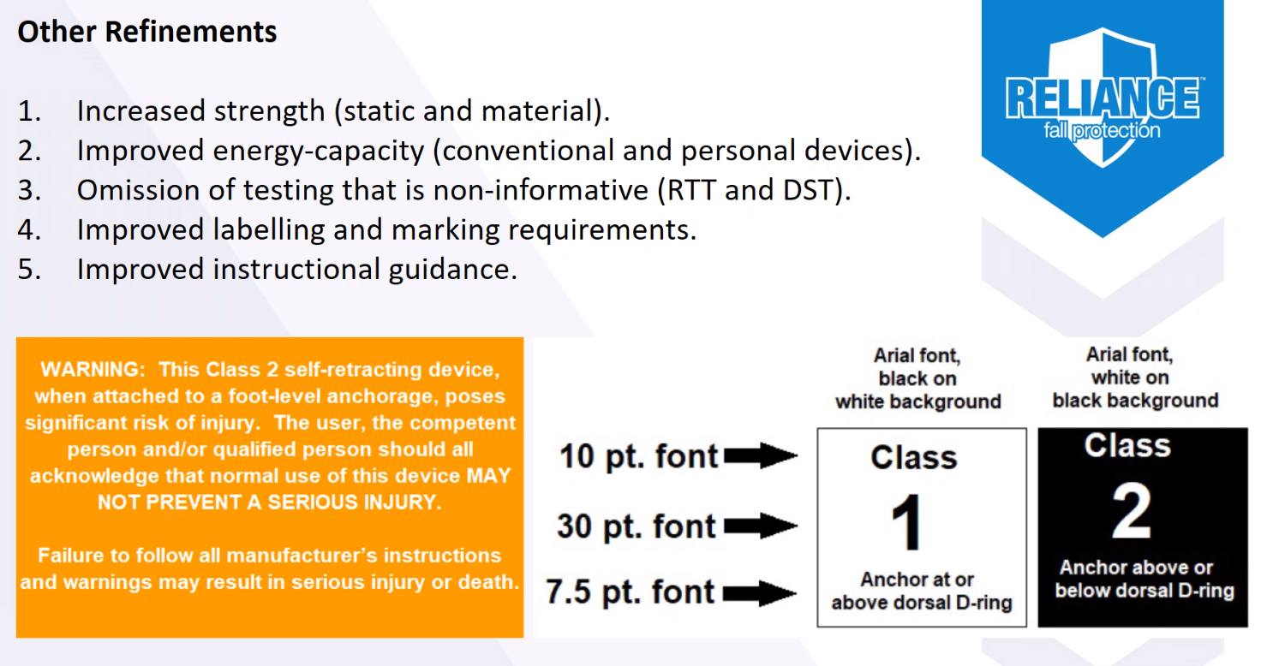
Appendix B – guidance to end user
Safe practices
Selection
Training
Use and limitations
Calculating clearance
Other PPE with fall protection, particularly with SLDs.
Dan also provided a sample memo with this group. Not approve, do not distribute publicly, do use it to educate.
What will manufacturers do with materials in house now? ANSI standards are voluntary, old products are not inherently unsafe or no longer allowable for use. If you have old products, keep using if they are serviceable. If they are no longer serviceable, reach out to provider and may consider new. Where we are introducing significant freefall potential do we want to upgrade, knowing these have not been rated for freefall in the past. Since Class 2 are now rated for swing fall, are we concerned that it will encourage people to accept freefall? Class 2 is now more robust, higher energy capacity, more cut resistant line that allows for tie off at foot level, however this is always something we should question and look at how we can elevate our anchorage. Foot level always last resort.
Don Hurley – very frustrated with one-size fits all requirement of our contracts and help educate our customers. A lot of customers require twin SRLs but that may not be the best choice. Has pushed back some but we as a group have a duty to educate customers to make sure our employees have the right device for the application and elevate the anchorage whenever possible. Catastrophic failures are likely if misused.
Alicia – Kietrack to Innate tool. Trying to get more data driven, identify region, districts, projects with greater risk. What features are driving this risk? What features indicate greater risk and based on this what can projects do to mitigate that risk? Happy to go into what analytics team went through to get to their predictive analytics. Actual hurts and potential hurts – currently plugging in actual hurts and actual incidents. Filter to district – Pulls in financial, organizational, development data…28 features that model identified for predicting hurts, 16 that are actually actionable. Top actionable features are what the project risk is based on. When target value is exceeded, increased risk of Hurt. Offer recommended actions (mitigation) based on risks and linked to best practices. Construction Manager and Supt historical IR = These supts or construction managers have had over the target rate of incidents in their past. Time they were on the project in that position title. Example – three previous projects this individual has been on that had higher than target rates – may not be their work but gives them the chance to have a conversation about what they saw, culture, etc…
Historical incident trends – pulls up market they are in, all incidents for region they are in, % complete pulled in from financial system, can select range of projects in similar completion stage as your job and where the injuries are happening. Can pull in actual event details as well as craft type, body part, tasks, etc…
Business Meeting:
Next meeting in person – Dallas – Travel in Monday, meeting Tues & Wed. April 11th – 13th. ½ day on 13th. Good bank account status – will add dues for 2022. JE Dunn (Eric Zuhlke) pulled off, STO would like to join – Keith. Amentum – Jeff – mix of construction, consulting, security, government contractor. Similar to KBR. Constructing housing for Afghan refugees, Construction, CM, based in Maryland. Skanska? Brad Farley – over buildings. Paul Haining – has not been interested. PCL has not shown in years. JE Dunn, who is there director now? Walsh – Jack Brazil went to Dunn, who is there now? GE Johnson – Joe has to come off as they were purchased by DPR. IEA renewable contractor, Kevin Turner.

